1. Created directory hw3.
2. Implemented a program (generate_keys) that will randomly generate 3072-bit RSA Key and will save public key in pub_key and Private Key in priv_key under the folder hw3 created in Step #1.

**Q0**: I used Python programming language. I used RSA library.

**Q1**: Using hexdump displayed pub_key and priv_key  
**pub_key**:

**Priv_key**:

1. Implemented the program encrypt_file that encrypts the given file sensitive.txt with the help of key Public Key available in pub_key

**Q2**: Screenshots of encrypted and unencrypted (original files):  
  
***Original file***:

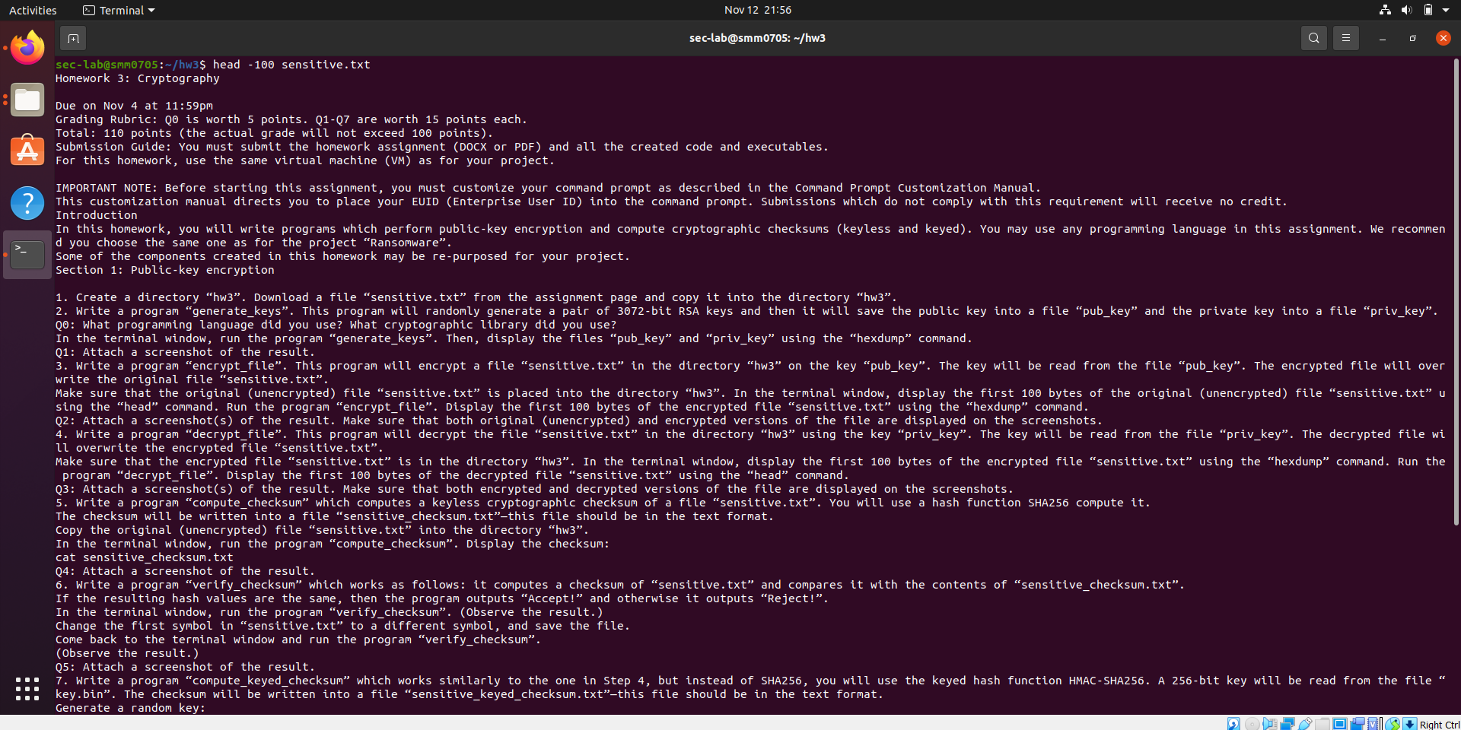

***Encrypted file***:

1. Implemented the program decrypt_file python program that reads the priv_key and decrypts the encrypted file

**Q3**: Executed the decrypt_file program on the terminal.

*Encrypted data:*

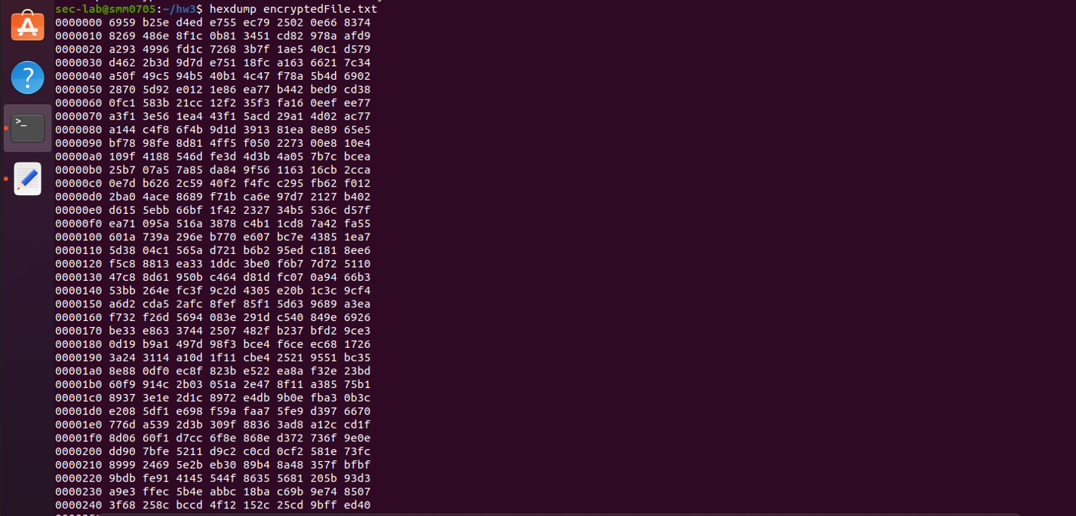

Result post execution of decrypt_file program:

1. Implemented the program compute_checksum using python programming language (used hash function SHA256 as instructed) and the check sum is written to sensitive_checksum.txt file.

**Q4**: Result of the check sum post compute_checksum execution on the terminal.

1. Implemented the python program verify check sum as per the given instructions.

**Q5**: Comparing the sensitive_checksum (obtained from step #5 and Q4) with check_sum of the sensitive.txt file.

*Comparison with original checksum on sensitive.txt file*:  
  
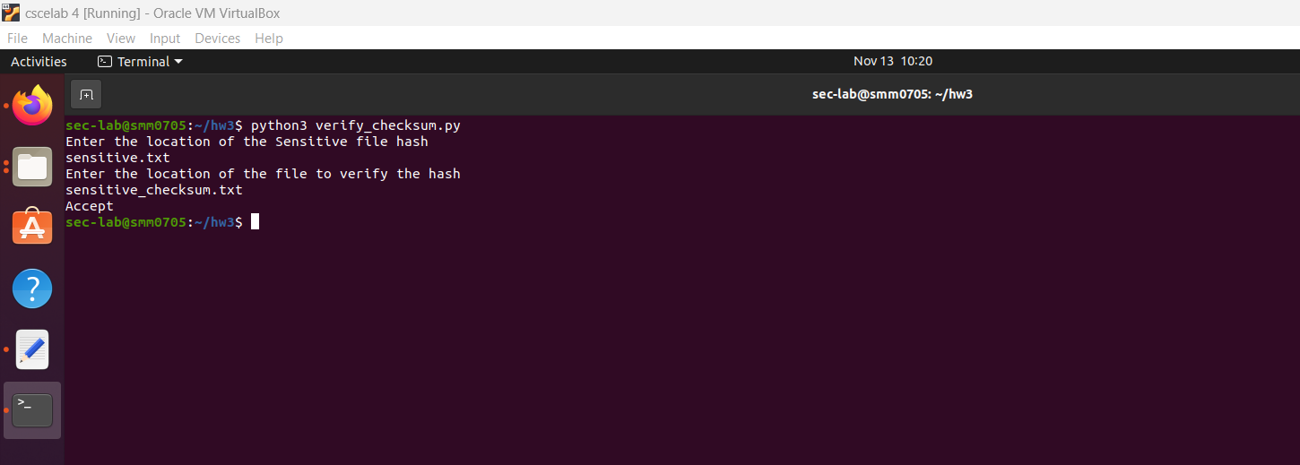

*Comparison on altered sensitive.txt file and sensitive_checksum.txt file:*

1. Implemented the compute_keyed_checksum as per the instructions in python using keyed hash function.

*Generate a random key:*head -c 256 /dev/urandom > key.bin

**Q6**: The result of compute_keyed_checksum post execution using cat command:

1. Implemented verify_keyed_checksum in python using HMAC-SHA256.

**Q7**: Comparing original file and file generated from #Q6 sensitive_keyed_checksum and got ‘Accept’ result.

**Original file**:

*Verifying keyed check sum of original file with compute keyed checksum of sensitive file:*

Changed sensitive.txt file computed keyed check sum and then compared it with sensitive_keyed_checksum.txt file:

